Hallcroft Infant
&
Nursery School



Handwriting Policy
December 2025

- Intention
We intend for our pupils to develop a comfortable, neat, legible, speedy handwriting style that leads to producing letters and words automatically in independent writing.
The development of a fluid handwriting style when mastered prevents the cognitive demands of letter formation from hindering other aspects of the pupil’s writing including composing, planning and revising.
At Hallcroft Infant and Nursery School our intentions are:
- Pupils are taught handwriting precisely, in a clearly sequenced progression, starting from reception, to support their gradual acquisition of skills.
- Consistency is provided through the use of the same terminology across all year groups.
- Teachers expect consistently high standards, making sure pupils practise handwriting regularly and consistently throughout the school to develop and maintain fluency and legibility.
- Pupils should be encouraged to take pride in the presentation of their work and know the importance of clear and neat presentation in order to communicate meaning effectively.
- To ensure that when they leave KS1, they are able to write legibly with well-formed letters with secure joins.
- Adults to model a high standard of handwriting, across all areas of the curriculum, when writing in children’s books, on the whiteboard or on displays / resources.
- Implementation
At Hallcroft Infant and Nursery School we use Anima Phonics ‘Letter bugs’ as the basis of our handwriting scheme, which covers all the requirements of the 2014 National Curriculum.
We use the terms ‘Sky, Grass and Ground’ to help the children understand where to place their letters once they are using lines (appendix 2) and the children will learn the formation of the letters through the Anima Phonics Letter Bug rhymes (appendix 4).
The children also learn the letter families where they are taught to develop a consistent style by paying attention to how letters in each family are formed. The ‘families’ are grouped according to where each letter starts (appendix 3).
Handwriting is taught in discrete lessons separate to phonic sessions.

Nursery
Expectations | Provision | Terminology Extended yearly | Resources
Teach and practice using and manoeuvring their thumb, wrist and shoulder muscles in the way they need for handwriting.  Learn the movements needed to form letters, practising these movements at a range of sizes (for example, in the air or, for some children, with fingers on a surface that leaves a trace)  Begin to learn how to hold a pencil in the correct position for writing.  Understand the key directional words such as, ‘up’, ‘down’, ‘round’ and ‘back’. | A weekly focused writing session  Throughout continuous provision. | Crocodile fingers  Snap snap  Rest in the pencil’s bed | Wax crayons, markers, pencils, sponges, chunky brushes, cotton wool balls, shaving foam, finger paints, sand, chalks etc.  Whiteboards
Reception
Expectations | Provision | Terminology Extended yearly | Resources
As above for children still consolidating those skills.  Continue to enhance gross motor skills such as air-writing, pattern making, dancing.  Continue to develop fine motor skills with activities such as dough disco, making marks on paper, whiteboards, blackboards, sand trays, iPads and tablets.  Learn how to hold and control a  pencil and the correct position for writing.  Introduce the systematic teaching of and practice in moving the pencil to master the horizontal, diagonal, vertical and circular strokes needed for writing.  Teach letter formation, focusing on:  -where to start each letter  -the direction of formation  -the shape  -the position  -the spacing relative to other letters | A daily handwriting session which is;  - taught in small steps, with opportunity for practice  - cumulative: teachers should build on what pupils have learned previously  - consolidated before teaching moves on so that pupils do not practise letters incorrectly  - revisited when further practice is needed  - demonstrated by the teacher  - additional to any handwriting that forms part of teaching phonics | Magnet eyes on me.  Red dot over your shoulder  Holding on the black and yellow  TNT – tummy near table  BBC – Bottom to the back of the chair  Dough Disco  Handwriting families  -Mantis family  -Stick Family  -Curly Caterpillar letters  -Special Letterbugs  Dough disco | As above.  Pencil for writing.  Move to Anima Phonics handwriting paper – grass, earth, sky when the children are ready, summer term.
Year 1
Expectations | Provision | Terminology Extended yearly | Resources
Sit correctly at a table, holding a pencil comfortably and correctly  Begin to form lower-case letters in the correct direction, starting and finishing in the right place  Form capital letters  Form digits 0–9  Understand which letters belong to which handwriting ‘families’ (i.e. letters that are formed in similar ways) and to practise these | Daily - 10 minute sessions | Six feet on the floor  Ascenders  Descenders | As above.  Anima handwriting lines grass, earth, sky – wide in English and handwriting books.  Narrower lines can be introduced once the children can write easily and legibly on wide paper.
Year 2
Expectations | Provision | Terminology Extended yearly | Resources
Form lower-case letters of the correct size relative to one another  Start using some of the diagonal and horizontal strokes needed to join letters and understand which letters, when adjacent to one another, are best left unjoined  Write capital letters and digits of the correct size, orientation and relationship to one another and to lower-case letters  Use spacing between words that reflects the size of the letters, so that later joins do not create extra, confusing shapes | Daily – 10 minute sessions | Diagonal join  Horizontal join | As above  Anima handwriting lines grass, earth, sky – narrow in English and handwriting books.  Wider lines to be continued for the children who are unable to write easily and legibly on the wider lines.

- Expectations
All teachers and support staff should:
- Have high expectations; valuing work that is the child's best effort and supporting when it clearly is not.
- Identify left handed children and make sure they have sufficient space in which to work.
- Working areas to have copies of handwriting mats.
- Provide appropriate paper and pencils (i.e. all pencils must be sharp and of a reasonable length).
- Reinforce how to form letters, using a variety of strategies and materials.
- Model consistently the correct pencil grip.
- Model good handwriting across all areas - on the board, in marking children's work and displays.
- Implement interventions for those children not forming letters or numbers correctly.
- Verbal feedback to be provided during the session. Teacher to model letter formation in a green pen.
- All work needs to be dated using the short date.

- Inclusion
Handwriting should be differentiated where necessary to meet all pupils’ needs.
Through continued assessment during sessions some pupils may be identified as needing further support discussions with the SENCO and Provision Maps will address this need. Outside agencies can be contacted where appropriate.
All teachers are to be aware of the specific needs of left-handed pupils (appendix 1) and make appropriate provision:
- Paper should be positioned to the left for right handed pupils and to the right for left handed pupils and slanted to suit the individual in either case.
- Pupils should be positioned so that they can place their paper to their left side.
- Left-handed pupils should sit to the left of a right-handed child so that they are not competing for space.
- Extra practice with left-to-right exercises may be necessary before pupils write left-to-right automatically.

- Monitoring
- The English Lead will monitor the standards of children’s work and the quality of teaching handwriting through lesson drop ins and work scrutiny.
- The English Lead is also responsible for supporting colleagues in the teaching of handwriting.
- Presentation of work, including handwriting, is monitored by the Senior Leadership Team on a regular basis through work scrutiny and lesson observations. Feedback will be shared with the class teacher and discussed at leadership meetings when appropriate. This will ensure that the policy leads to good practice
- The English Governor monitors handwriting during learning walks and visits with the English lead.
Appendix 1
Maintaining a correct and comfortable sitting position and pencil grip
Teachers should encourage pupils to maintain correct finger positioning. Most pupils find the tripod grip the easiest to learn and support grips can help. Teachers should show pupils how to pinch the pencil with the index (‘pointing’) finger and the thumb, about a finger space from the end (on the coloured part just above the sharpened point); and how to rest the middle finger underneath the pencil to support it. If necessary, a sticker can show pupils where to place their fingers. The way a child grips the pencil will affect the quality, speed and flow of the handwriting. The grip should be relaxed, not pressing too hard on the pencil or the paper.

Finger positioning using the tripod grip:
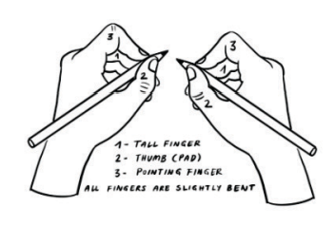

Pencil positioning using the tripod grip:
1) Pick up the pencil with your crocodile fingers.
2) Lift up the pencil to rest it in the bed (soft part of hand between thumb and first finger). Use your crocodile fingers to support the pencil.
3) Red tip of pencil should point over your shoulder.

Paper positioning for left-handers: Paper positioning for right-handers:
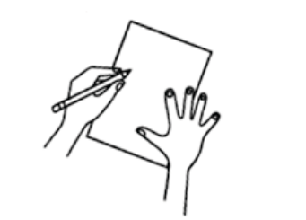
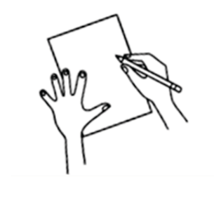

Seating position:
Bottom to the back of the chair - BBC
Tummy near table – TNT
Two hands – one holding paper, one holding pencil
Six feet on the floor

Appendix 2
Reception Wide Handwriting Lines
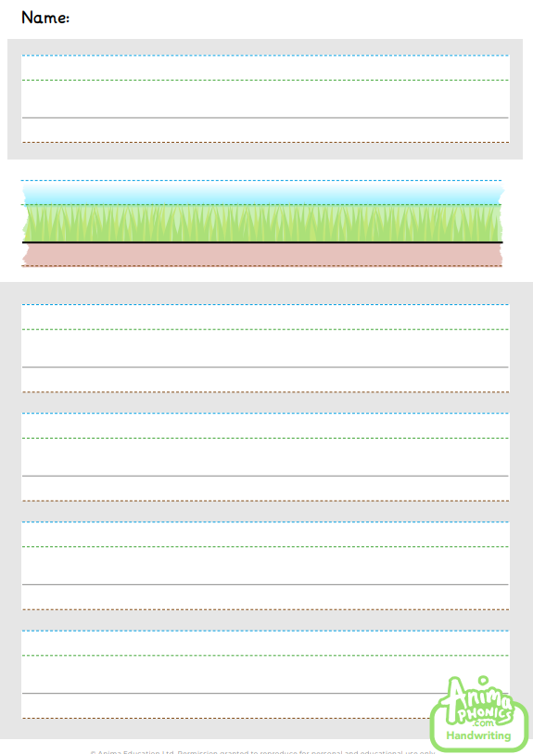

Appendix 2
Year 1 Handwriting Lines
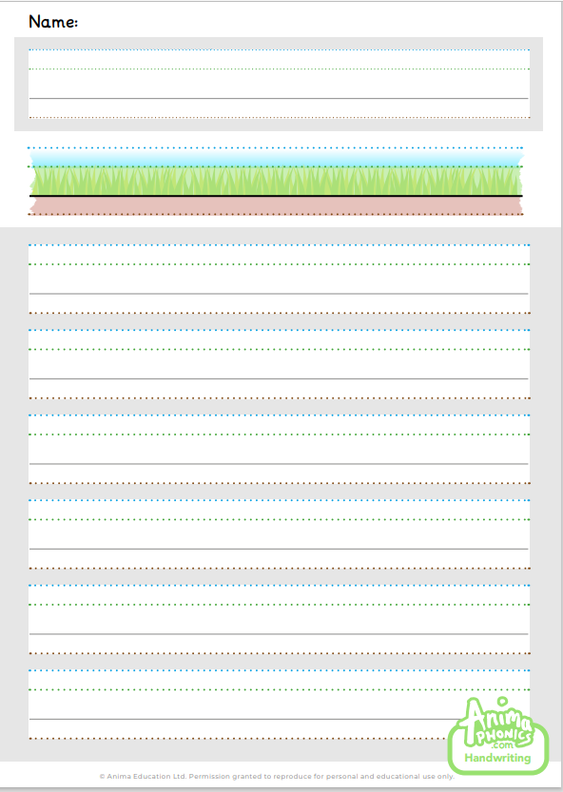

Appendix 2
Year 2 Handwriting Lines
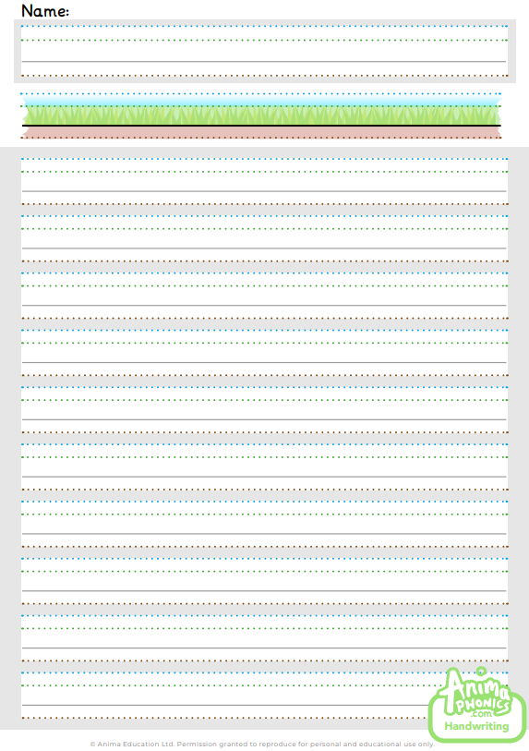

Appendix 3
Letter families and relative sizes
Pupils should be taught to develop a consistent style by paying attention to how letters in each family are formed.
The ‘families’ are grouped according to where each letter starts.
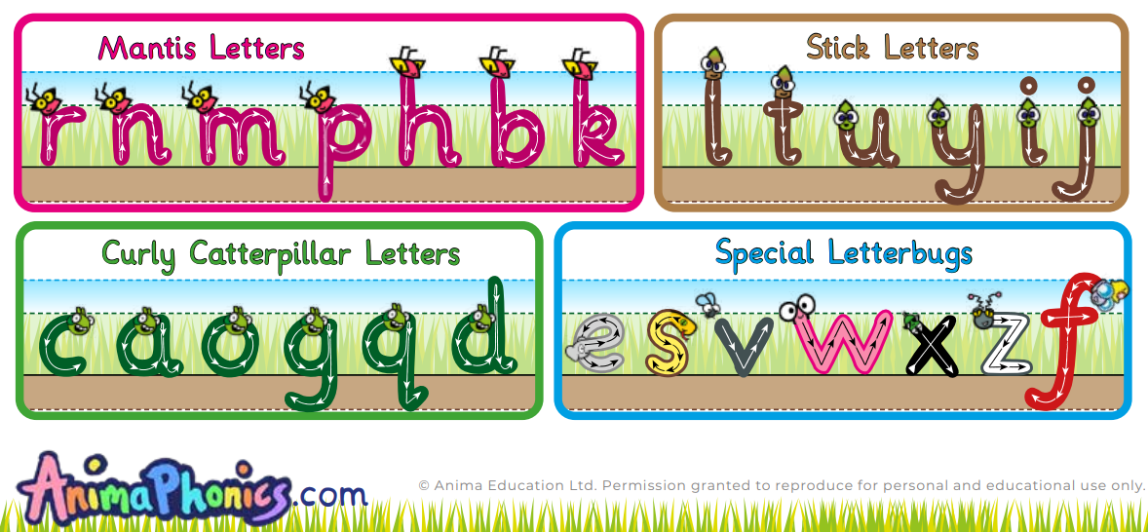

Appendix 4

Letter rhymes
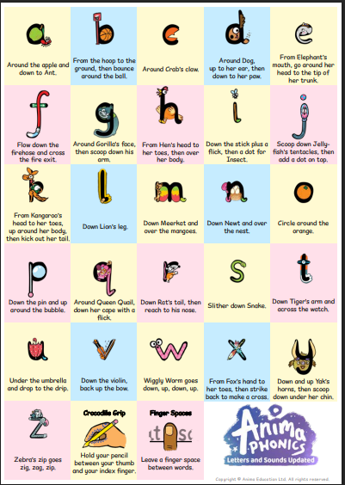

Appendix 5
Y2 Handwriting Joins

Pupils should be taught two basic joins: diagonal joins and horizontal joins.
The diagonal join connects:
• letters from the line to small letters
• letters from the line to tall letters
• letters from the line to a, d, g, c, o, q (These letters need an extra stroke backwards across the top of a, d, g, c, o.)

The horizontal join connects:
• v, w, x, f, r to small letters
• v, w, x, f, r to tall letters
• v, w, x, f, r to a, d, g, c, o, q

