Hallcroft Infant
&
Nursery School

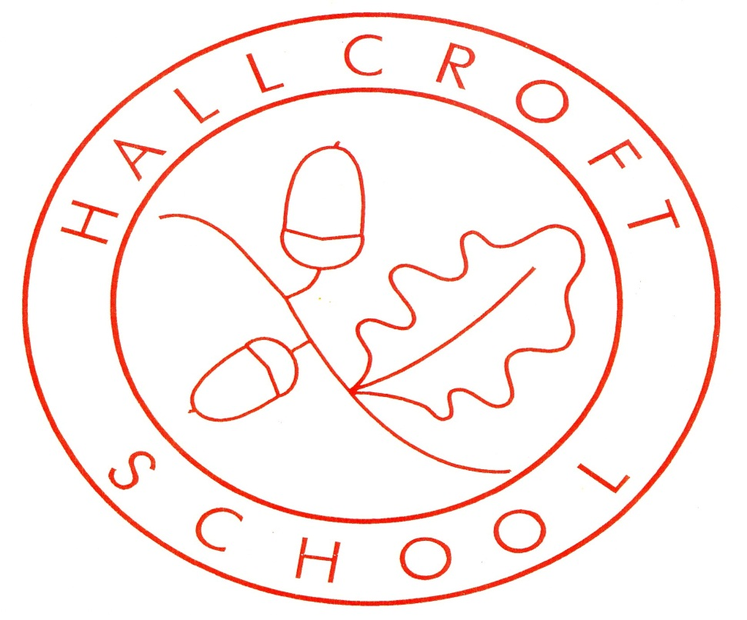

Reading & Phonics Policy
October 2025

Introduction
At Hallcroft Infant and Nursery School, we believe that reading is a vital skill that will support children’s learning throughout their schooling and future lives. The reason we developed our curriculum with such a strong emphasis on reading is reflected in the Michael Morpurgo quote:
“Reading is the one ability that, once set in motion, has the ability to feed itself, grow exponentially and provide a basis from which possibilities are limitless.”
As a school, we ensure that our children are taught to read with fluency, accuracy and understanding through a variety of discreet and cross-curricular learning opportunities. Above all, we want children in our school to become enthusiastic, independent and reflective readers. Therefore, all staff promote and value reading as both an enjoyable activity and as a life skill.

This policy is a statement of the aims, principles and strategies for the teaching and learning of Reading at Hallcroft Infant and Nursery School. The policy should be read in conjunction with the Early Years Foundation Stage framework and the 2014 National Curriculum.
Aims
We aim to deliver a high-quality reading curriculum that will give our pupils the opportunity to:
- Acquire decoding skills by following the Anima Phonics scheme.
- Use the reading skills that they have acquired effectively in a range of contexts.
- Develop a deep love and understanding of English literature and language.
Intention:
To fulfil our aims the children will:
- Gain the phonics knowledge and language comprehension necessary to read which will give them the foundations for future learning.
- Have developed a wide range of vocabulary which they use to understand texts and that they can use when speaking formally and informally.
- Become avid readers who can read fluently and widely and are able to express preferences and opinions about the texts that they have read.
- Read for pleasure and have had access to a diverse range of texts, genres and authors.
- Have had early experiences of reading which will have been delivered in engaging ways to develop positive attitudes towards and a love of reading.

Implementation
At Hallcroft Infant and Nursery School, we have developed a reading curriculum which develops the pupils’ fluency, confidence and enjoyment in reading. The curriculum is designed to be rigorous and sequential, ensuring that all children make progress regardless of barriers and that any gaps in learning are addressed quickly and effectively.
The key elements of the phonics and reading curriculum include:
F1
- Pupils follow the Super Sounds phonics scheme, which through books, songs and
interactive activities develop listening and blending skills to prepare them for the
next stage of phonics in Reception.
- Pupils are introduced to ‘Our Ten Favourite Books’. These familiar and well-loved texts help pupils develop story language, confidence and a sense of security with books- especially supporting those with limited early reading experiences.
- Pupils take home a weekly library book to encourage early reading opportunities and foster a love for reading.
- Children are teacher-assessed each half term to see if they are on track, need support to stay on track or are off track from taught objectives.
F2
- Pupils follow the Anima Phonics Scheme, which provides a structured and progressive
approach to phonics.
- Pupils take home Anima Read and See decodable books closely matched to their
phonics level. Phoneme flashcards and common exception (Rainbow Word) flashcards
aim to reinforce learning in lessons and support recall. From Phase 3 onwards, an
additional Anima book is given to enable children to practise decoding sentences and
to develop reading fluency.
- Pupils are encouraged to take home a library book to share with their grown up to
encourage reading for pleasure.
- In F2, the children are introduced to ten new books which become the class’s ‘Ten Favourite Books’. These become familiar and well-loved texts which continue to help pupils develop story language, confidence and a sense of security with books- continuing to support those with limited early reading experiences.
- We aim for children to read individually to an adult at least once a week in school. The adult will write a positive focused comment identifying a reading skill that the child has performed well and provide a next step that the child needs to work on both at home and school.
- Focus children recall recently learned phonemes and read to an adult 1:1 daily.
- Pupils entering Reception who require additional phonics support are identified early through a baseline assessment. Targeted interventions for these pupils include oral
blending activities, one-to-one phoneme practice sessions and blending to read
booster groups.
- At the end of each phonics phase, pupils are assessed using Phonics Tracker.
- In the summer term, the Reception Phonics Screening Check is used to evaluate overall progress in decoding and blending in readiness for Year 1.

Y1
- Pupils continue to follow the Anima Phonics Scheme.
- Pupils read their phonetically decodable book in small groups, three times weekly. These guided groups help to support readers with vocabulary acquisition, reading intonation and expression.
- Once per week, an adult will write a positive focused comment identifying a reading skill that the child has performed well and provide a next step that the child needs to work on both at home and school.
- Focus children will recall recently learned phonemes and read to an adult 1:1 daily.
- Pupils will take home an Anima phonetically decodable book, phoneme and Rainbow Word flashcards and a library book each week to promote enjoyment and practice of reading.
- Pupils requiring additional phonics support attend morning practice groups or receive 1:1 intervention as needed.
- The children will have access to the classes ‘Ten Favourite Books’—familiar texts that support understanding and boost reading confidence.
- Pupils complete an initial baseline assessment and are assessed using Phonics Tracker at the end of each sub-phase.
- Progress is reviewed half-termly and Phonics Screening checks are conducted each half term.

Y2
- Pupils continue to follow the Anima Phonics Scheme, which progresses into spellings for Year 2.
- Pupils read their phonetically decodable book in small groups, three times weekly. These guided groups help to support readers with vocabulary acquisition, reading intonation and expression.
- Once per week, an adult will write a positive focused comment identifying a reading skill that the child has performed well and provide a next step that the child needs to work on both at home and school.
- Pupils take home an Anima book that is closely matched to the previous week’s teaching or their phonics level.
- More able readers are encouraged to select an additional book, allowing them to make independent choices based on their interests and further develop their enjoyment of reading. These texts are often longer to help build reading stamina and may also include the classes Ten Favourite Books—familiar texts that support understanding and boost reading confidence.
- All children take home a library book to grow their love of reading.
- Focus children read 1:1 with an adult daily.
- Pupils requiring additional phonics support attend morning practice groups or receive 1:1 intervention as needed.
- Pupils who did not meet the expected standard at the end of Year 1 Phonics Screening Check or require further support, continue to receive daily phonics lessons, alongside Phase 6 spelling.
- An initial baseline is completed to inform planning and targeted interventions.
- Progress is reviewed half-termly and Phonics Screening checks are carried out each half term.

Reading for Enjoyment
All pupils have opportunities to read for pleasure and learn to enjoy reading. This happens across continuous provision and at direct teaching time in Early Years and at various points in the week in KS1. All pupils in school can access the book hut if they want to choose books to share with adults at home and in addition, pupils in KS1 take a “library book” home which they change once a week.

Staff Commitment
At Hallcroft Nursery and Infants, early reading development is a key priority. All staff, particularly support staff, are expected to use every available opportunity to listen to readers or support phonics/reading. The aim of this is to ensure that every child makes progress. Reading checklists must be readily available in classrooms so that any adult can quickly see which children have read, or are yet to read, that day or week- enabling time to be used effectively. Pupils who require additional reading practice should be highlighted with a star, allowing them extra opportunities to read. Each class must have a clear, weekly timetable which details reading focuses, when they happen and who leads them. This is to ensure that all pupils’ needs are met and that reading remains a foremost priority. At Hallcroft, we promote the principle that we are all teachers of reading. Every opportunity—whether during Breakfast Club, afterschool activities or utilising volunteers can be used to support children to read, read to them, or immerse them in discussions about stories and books.

Quality Texts and Shared Reading
Numerous opportunities to read arise through our Anima Phonics scheme, with the whole class encouraged during lessons to apply their phonetic knowledge, alongside independent application activities. In addition, we are committed to exposing pupils to a wide and diverse range of literature. In the EYFS, a different focus story is chosen each week to act as a hook for independent learning and writing, and the text is available for children to explore themselves in the Discovery area. Books linked to White Rose Maths learning are also read, and diverse stories are embedded throughout curriculum planning.
In KS1, high-quality texts are read that link to English lessons, as well as significant titles supporting learning across the curriculum. Fiction and non-fiction texts related to the term’s learning are on display in every classroom to support vocabulary development, knowledge acquisition, and reading across the curriculum, while also increasing pupils’ cultural capital. Diverse representation is a key consideration in all texts chosen.
Of particular importance across the school is our designated daily Story Time, during which children listen to and share in the enjoyment of reading, fostering a love of stories and books.

Group Reading Practice (KS1)
This takes place 3 x weekly in KS1. Pupils read their phonetically decodable book in small groups, three times weekly. These guided groups help to support readers with vocabulary acquisition, reading intonation and expression.

Word Aware
To ensure that pupils have some direct vocabulary teaching, pupils in KS1 take part in daily Word Aware sessions.
This daily session teaches vocabulary in a very structured way and introduces a range of vocabulary including; curriculum based vocabulary, specific academic words, emotional literacy words and some positional language in Y1. Each week, “fridge words” are sent home to share with parents/carers who can discuss the week’s vocabulary with their children. In EYFS vocabulary is taught across the curriculum and continuous provision and also at specific times e.g. in Drawing Club lessons, Jigsaw, Phonics. In Nursery, vocabulary is also taught as a weekly planning focus
School Events
Each half-term every class holds a ‘Books and Biscuits’ event where parents are invited into school to share a book with their child and celebrate reading for pleasure. The school also invites Paul Cookson a local poet/author in regularly and we have also enjoyed a visit from Grandad Wheels who shared the books he had written with the pupils. We proudly have a Reading Shed in the playground whereby our families can share and swap books.
Reading Incentives
The school promotes reading at home through a reading award scheme. The children are encouraged to read five times per week with an adult. The number of reads that the child reads are tallied each week and the children receive a prize when they reach each award; ranging from being front of the dinner line to nibbling chocolate with Mrs Cook.
Phonics Assessment
Children’s progress is closely monitored through frequent formative assessments in lessons, during 1:1 reading, and when recalling phonemes on flashcards. At the end of each phase, children are formally assessed using the Phonics Tracker, which records the phonemes they recognise and their ability to blend them in words. The Tracker also monitors the common exception words (Rainbow Words) that children can read independently. Individual pupil progress, based on the half-termly Phonics Tracker assessments, is shared with parents in their Home Reading Diary. Practice Phonics Screening Checks are completed half-termly from the summer term in Reception. In June of Year 1, all children take part in the national Phonics Screening Check, and any child who does not meet the required standard will retake the assessment in Year 2.
Reading Assessment
Children’s reading levels are assessed using statements from the EYFS and the KS1 National Curriculum programmes of study. Progress in reading is monitored termly in the Early Years and at six points throughout the year in KS1. Whether pupils have met the expected standard is shared with parents annually in their report, including if they have met or not met a Good Level of Development (GLD) in Reading at the end of Reception.
Supporting Vulnerable Learners
Regular assessment is carried out to ensure the early identification of children who may need us to provide them with extra support, either through daily 1:1 reading, interventions or during daily classroom teaching. As soon as we identify any child who is struggling to succeed in phonics and early reading, the provision will be put into place to close the gap.
Reading Environment
All classrooms feature inviting reading areas that children choose to use regularly. Books linked to current subjects and topics are prominently displayed and in the Early Years, books are integrated into the continuous provision across all areas. Anima Phonics displays provide a visual reference for children to support and extend their daily phonics learning. These working walls showcase key weekly learning, previously taught graphemes and ‘Rainbow Words,’ helping children develop independence. Across all classrooms, we promote a language-rich environment. In Key Stage 1, Word Aware displays further enhance vocabulary development by supporting the teaching of new words.
Home Learning Expectations
Parental involvement plays a vital role in the acquisition of phonics and helps us maintain a cohesive, whole-school approach. At the start of the Autumn term, each class hosts a phonics workshop for parents and carers. During these sessions, we share key information and techniques, such as articulating pure sounds and blending, so that families can use the same strategies at home that children are learning in school.
Parents can access the Anima Phonics soundboard and other useful website links via the school website to further support learning. Phonically decodable reading books and phoneme flashcards are also sent home to reinforce phonics and reading practice. Each child receives a reading record diary, providing a way for teachers and parents to track progress and celebrate achievements in reading.
We encourage pupils to read at home five times per week. Parents are asked to support this routine, and regular reading is celebrated through our reading rewards programme.

Equal Opportunities
All children regardless of protected characteristic have equal access to the range of activities and experiences offered in English.
Inclusion
All children will have access to all areas of reading and phonics. Children with SEND will be supported with the necessary adaptations according to their individual needs and abilities to enable them to progress.
Responsibilities and Review
All teaching staff have responsibility for implementing all aspects of this policy. The English and Phonics Subject Leaders have the role of monitoring reading and phonics through lesson drop ins, book scrutiny, planning scrutiny, discussions with pupils and teachers and environment walks.

Reading & Phonics Policy updated by – Jo Cook October 2025

