Hallcroft Infant
&
Nursery School

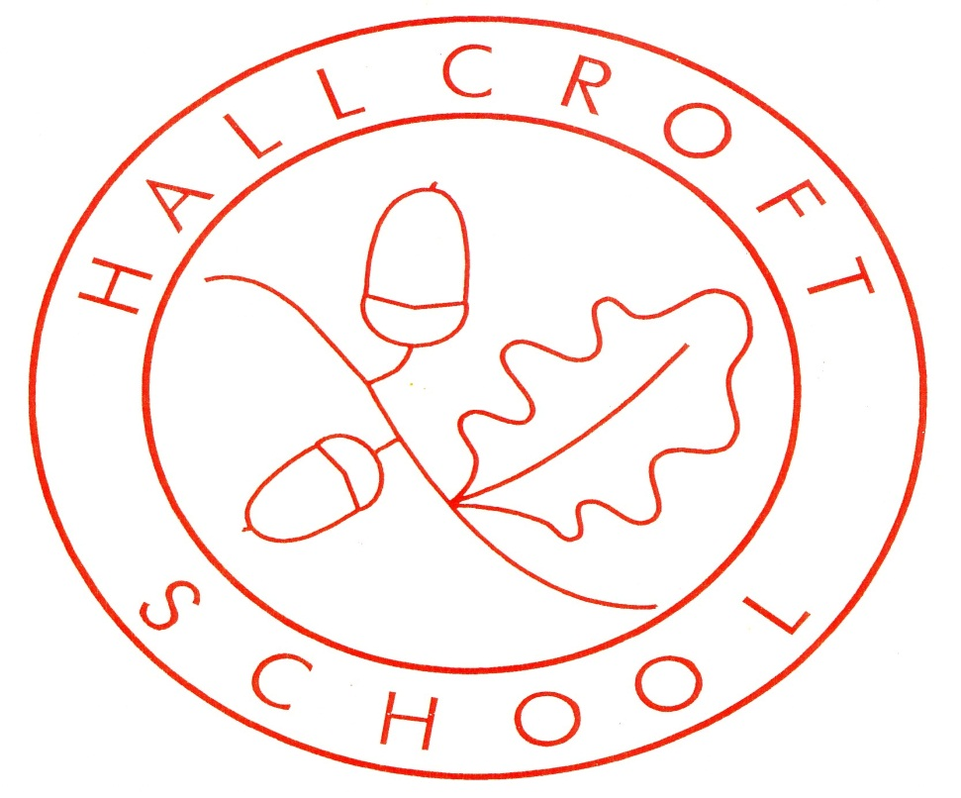

Science Policy
January 2024

Introduction
At Hallcroft Infant and Nursery School, we strive to deliver a high-quality science curriculum which allows our pupils to recognise the significance of science in their everyday lives. This will allow the children to access a broader understanding of the world around them from a scientific viewpoint. We believe that the science curriculum should inspire pupils with a curiosity and fascination about natural phenomena and the uses and implications of science, today and for the future, that will remain with them for the rest of their lives. Children should have opportunities to observe the world around them and to become familiar with the natural and humanly-constructed world. They should also be taught, and feel comfortable using appropriate scientific language.

Aims
We aim to give our pupils the opportunity to:
- To become little scientists and build on the children’s natural curiosity
- Develop scientific knowledge, skills and conceptual understanding.
- Inspire them to investigate, question and develop attitudes of science
- Teach them to communicate ideas using appropriate scientific language.
- Teach them how to evaluate their findings and suggest explanations.

Intent
To fulfil our aims, we will:
- Have engaging Science lessons which will give the children first hand experiences, and develop their skills, knowledge and understanding in science.
- Teach Science once a week throughout school.
- Learn about key scientists, significant discoveries and theories to give the children a real-life understanding of the concepts taught.
- Teach age-appropriate subject-specific vocabulary relating to scientific learning.

Implementation
Foundation Stage
Science is taught in Nursery and Reception through the EYFS Development Matters Curriculum in a cross curricular approach. Relevant areas include;
- Understanding the World: The Natural World.
- Physical development
- Personal, Social and Emotional Development: Managing Self
- Communication and Language: Listening, Attention and understanding
Characteristics of Effective Learning: Playing and Exploring, Active Learning, Creating and Thinking Critically support children’s learning across all areas.
This enables early years to explore scientific themes and content and begin to develop sense of their physical world. The children look at plants and animals, including humans, seasonal change and begin to investigate materials.
Key Stage 1

Science is taught according to the requirements of the National Curriculum programmes of study.
Subject content KS1:

Year 1
- Working Scientifically
- Plants
- Animals, including humans
- Everyday Materials
- Seasonal Changes

Year 2
- Living things and their habitats
- Plants
- Animals, including humans
- Uses of everyday materials

In KS1, the science curriculum is delivered through cross curricular topics with subject specific lessons. Children will be involved in whole class discussions, group work and individual recording. Activities will develop the “working scientifically” enquiry skills through asking and answering simple questions, gathering and recording data and through discussions of what has been found out. Lessons make effective links with other curriculum areas and subjects, especially Literacy, Mathematics, and ICT. Activities are challenging, motivating and extend pupils’ learning. Pupils have frequent opportunities to develop their skills in, and take responsibility for, planning investigative work, selecting relevant resources, making decisions about sources of information, carrying out activities safely and deciding on the best form of communicating their findings.

Specific details of what is taught and when are outlined in the Subject Knowledge Plans, with detailed expectations of content written in the Knowledge Organisers for each half term. The Knowledge Organisers also identify key texts which support the development of scientific knowledge.

Resources
There are resources in school to carry out scientific tests and experiments. In the foundation stage, the resources are kept in classrooms. In KS1, resources are kept in a central area and additional resources for specific topics are ordered into school when relevant e.g. plants.

Equal Opportunities
All children regardless of gender, age, creed, ethnicity, (or any other protected characteristic) aptitude or ability have equal access to the range of activities and experiences offered in science.

Special Needs
All children will have access to all areas of the Science Curriculum. Children with SEND will be given differentiated science tasks, according to their individual needs and abilities.

How to help at home
- Every half term the school website is updated with current Knowledge Organisers relating to the learning for that half term; enabling parents to support learning at home.
- Encourage your child to ask questions about the world in which they are growing up in.

Assessment and Recording
- Each term every child in EYFS is assessed using the EYFS Development Matters document and given an attainment level in months.
- By the end of KS1 children are expected to know, apply and understand the skills and knowledge outlined in the relevant program of study for science; as detailed in our Science End Points.

Responsibilities and Review
- All teaching staff have responsibility for implementing all aspects of this policy.
- The Science subject leader has the role of monitoring Science through lesson drop ins, online work scrutiny, discussions with pupils and teachers and environment walks.
- The Science subject leader will review this policy and the curriculum as required.

